Freedom of Information Request
Requesting information under Freedom of
Information (FOI) Act 1982 from CFA

Advice for individuals
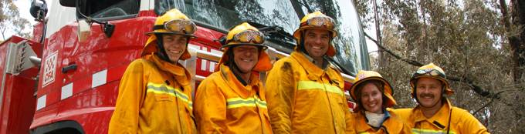
Your assistance in providing the requested information is appreciated and will assist in limiting time delays in processing your request.
Please be as specific as you can about the type of documented infrormation you are seeking access to, including a date range, as this assists the FOI Officer in locating and identifying information relevant to your request.
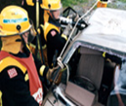 |  | 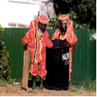
How to apply
The Freedom of Information Act 1982 (the Act) gives you the right, as far as possible, to access documents about your personal affairs and the operations of government agencies; it also provides the right to request amendments to documents that contain your personal information, where the information is inaccurate, incomplete, out of date or gives a misleading impression.
From 1st July 2016 the following information will be required when submitting a new application.
The application fee - $27.90*
The fee is set by government & changes annually on 1st July. (*$27.90 as of 1/7/16)
Your details and a copy of your identification - Name, D.O.B, address, licence etc.
The date and nature of the incident or matter.
Your involvement in the incident or matter - (e.g. passenger, property owner, witness etc.)
The specific documentation you are seeking access to – including a date range
Fire/Incident Reports and/or Fire Investigation Reports

Please note that Fire/Incident Reports and/or Fire Investigation Reports are available for purchase from our Fire and Incident Reporting Systems (FIRS) department and are therefore not subject to or available through FOI.
Section 14(1)(b) of the Act provides that a person is not entitled to obtain access under Part III to:
“a document which contains information that is available for purchase by the public in accordance with arrangements made by an agency;”.
CFA has such an arrangement.
Should you wish to obtain access to the Fire/Incident Reports and/or Fire Investigation Reports and photographs please contact the FIRS department on (03) 9262 8436 to arrange access.

Need more information?

If further information is required about any aspect of the Act, this can be obtained from the following web sites: foi.vic.gov.au or vcat.vic.gov.au

Contact Details
CFA Postal Address | CFA Headquarters | Email: foi@cfa.vic.gov.au
Freedom of Information Officer  PO Box 701  Mt Waverley Vic 3149 | Freedom of Information Officer  8 Lakeside Drive  Burwood East Vic 3151 | Telephone  (03) 9262 8512


Freedom of Information Request
Request for information under the Freedom of Information Act 1982 ('the Act')
Name of applicant: ________________________________________________________________________
Date of birth of applicant: (if the application relates to yourself) _____________________________________________________
Address of applicant: ______________________________________________________________________
Telephone contact details: __________________________________________________________________
Email contact details: ______________________________________________________________________

our releationshiup to the matter you are seeking information about? E.g. property owner, witness to incident, driver of vehicle etc. ________________________________________________________________________
________________________________________________________________________________________

Information requested: To assist CFA in locating specific documentation, it is important that you describe in detail what you are seeking access to; including the documents you require. The information you include should also identify the relevant date/s, location of incident/s, time/s, details of known parties, and any other information you deem relevant which will enable this office to conduct a search for information on your behalf.

A cheque or money order in the amount of *$27.90 (*$27.90 as of 1 July 2016) made out to CFA together with a copy of your identification is required at the time of your application. You may apply for information online at www.foi.vic.gov.au, however the application fee is still required to be posted or you may send your request in writing to the below address.
Freedom of Information Officer - CFA
PO Box 701
Mount Waverley Vic 3149
If you are seeking access to Fire/Incident Reports and/or Fire Investigation Reports these are available for purchase from CFA’s Fire and Incident Reporting Systems department (FIRS) – not FOI. If you wish to obtain access to these reports, reference must be made to section 14(1)(b) of the Act as they are not available via Freedom of Information. Please contact (03) 9262 8436 to arrange access to the reports.
If you have any queries please do not hesitate to contact the FOI Officer on (03) 9262 8512.

