12/19101

8 February 2013

Mr Brendan Molloy
Secretary
Pirate Party of Australia

Sent by email only to: Brendan Molloy foi+request-34-d2807add@righttoknow.org.au

Dear Mr Molloy
FOI REQUEST
I refer to your request under the Freedom Of Information Act 1982 (Cth) (“the Act”) made to the Attorney-General’s Office on 10 December 2012, revised on 14 January 2013 seeking:

All documents on potential legislative change to intellectual property law resulting from the final agreed text or most recent draft texts of the following treaties and trade agreements:

(i) Trans-Pacific Partnership Agreement
(ii) Anti-Counterfeiting Trade Agreement
(iii) Malaysia-Australia Free Trade Agreement
(iv) Japan-Australia Free Trade Agreement
Decision – Parts (i), (iii) and (iv)
I am authorised, pursuant to arrangements made by the Secretary of this Department under section 23 of the Freedom of Information Act 1982 (the Act), to make decisions in relation to this matter.
After having made appropriate searches and enquiries within the Department, I must advise that the Department is not in possession of any documents of the type you have requested. I must therefore refuse your request under section 24A of the Act. That section allows an agency to refuse a request if all reasonable steps have been taken to locate the documents sought and it is satisfied that the documents do not exist or cannot be found. For the above reason, I am satisfied on this occasion that documents of the type you have requested do not exist.

Decision – Part (ii)
I have examined closely the documents you have requested. I have decided, however, not to release them to you.
Section 26 of the Act provides that where access to material has been denied to an applicant under the Act, the decision maker shall provide the applicant with a written statement setting out the findings on material questions of fact, the material on which those findings are based and the reasons for the decision. Such information, in relation to my decision on this occasion, is set out below.
Findings on Material Questions of Fact
My finding on material questions of fact is that the documents you have requested contain:
- Legal advice.
Material on Which Those Findings are Based
The material on which those findings are based consists of the documents themselves.
Reasons for Decision
The reason for refusing you access to the documents is, in short, that they are exempt from disclosure under the Act. The provision of the Act under which the documents are exempt, and the reasons why I believe they are exempt, are set out below.

Section 42

The material is, in my view, exempt from disclosure under section 42(1) of the Act. That section provides:

“42 (1) A document is an exempt document if it is of such a nature that it would be
privileged from production in legal proceedings on the ground of legal professional
privilege.”

The material exempted under this provision has been exempted because I am satisfied that it would be privileged from production in legal proceedings on the ground of legal professional privilege. That privilege has not been waived, either expressly or impliedly.
Rights of Review
Should you wish to seek a review of my decision in this matter you have two options. You may seek an internal review by a senior officer of the Department. If you wish to pursue this course of action, you should forward an application to me within 30 days of the date of this letter.
Alternatively you may seek a review of the decision by writing to the Office of the Australian Information Commissioner (OAIC). The OIAC also investigates complaints should you wish to complain about any aspect of the way in which your request has been handled. Applications for review by the OAIC should be sent to GPO Box 2999 Canberra ACT 2601 or to enquiries@oaic.gov.au. Further information can also be found at www.oaic.gov.au.

Yours sincerely
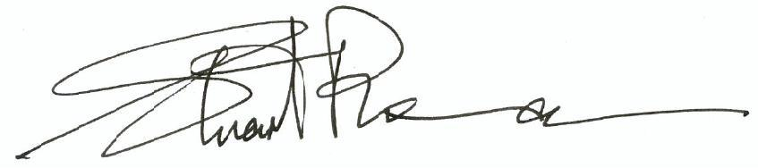
Stuart Plowman
Legal Officer, FOI & Privacy Section
Office of Corporate Counsel
Attorney-General’s Department
3-5 National Circuit
BARTON ACT 2600
Telephone: (02) 6141 4105
Email: stuart.plowman@ag.gov.au

